**Experiment -2.1**

|  |  |
| --- | --- |
| **Student Name:** Akansh Arya | **UID:** 22BDO10027 |
| **Branch:** CSE-DevOps | **Section/Group:** 22BCD-1/A |
| **Semester:** 4th | **Date of Performance:** 07/01/2024 |
| **Subject Name:** Git and Hub | **Subject Code:** 22CSH-293 |

1. **Aim/Overview of the practical:** Editing a file and committing changes on GitHub.
2. **Apparatus/Software Used:** Git Bash, GitHub.

1. **Steps for experiment/practical:** 
   * First open GitHub, to create a repository “Exp4”, then clone it in git bash.

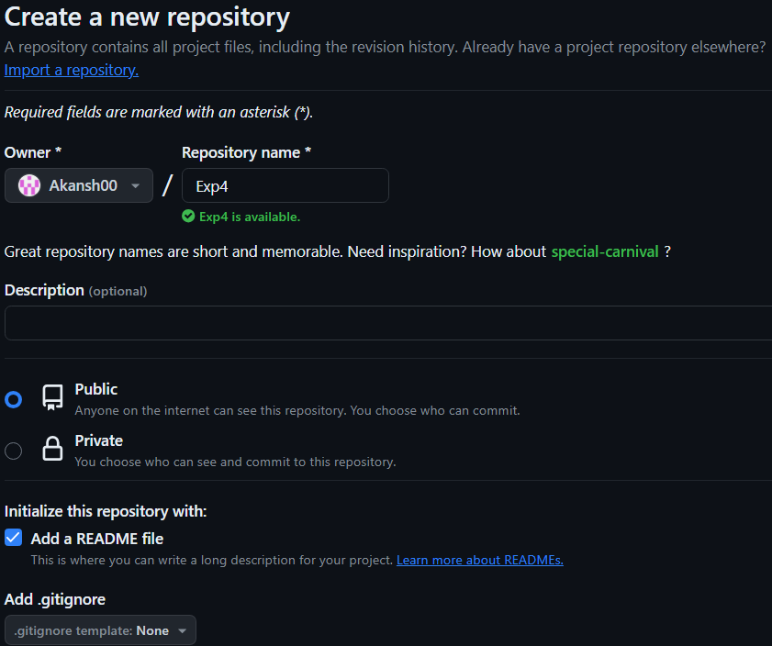

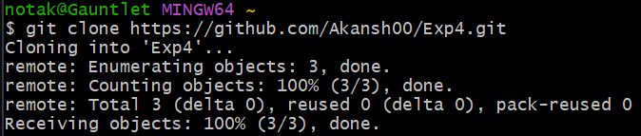

* + Then move to the directory using the **cd** command, and then create a file named ‘file1’ and add some text to it.

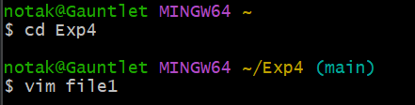

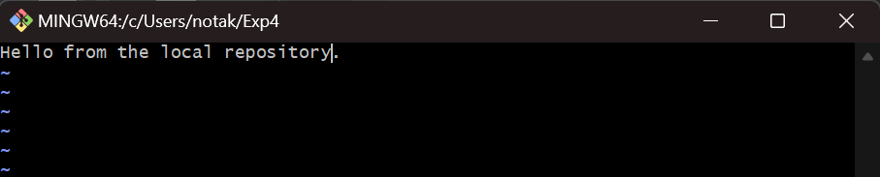

* + Add it to the staging area by git add command and commit it while adding a message using git commit -m “message”.

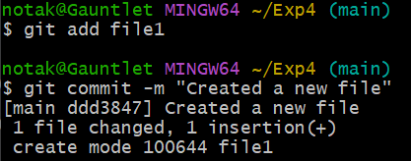

* + Now push the changes to remote repository.

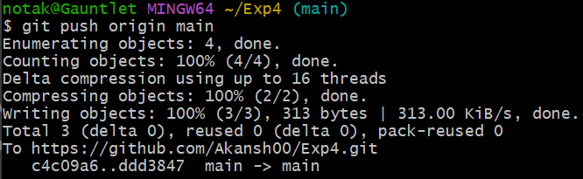

* + You can see the changes in the remote repository.

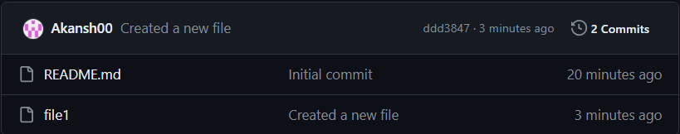

* + Now make some changes in the same file from the remote repository.

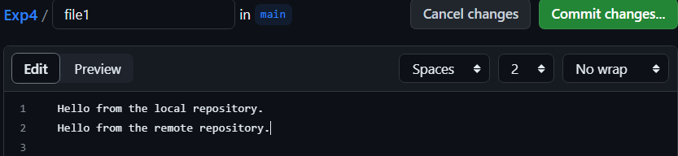

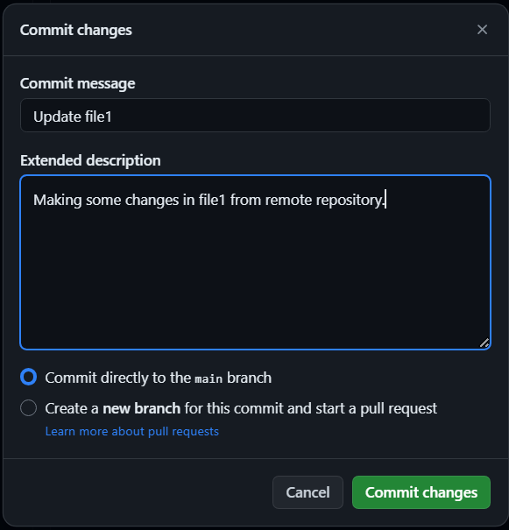

* + Now, pull your changes to the local repository.

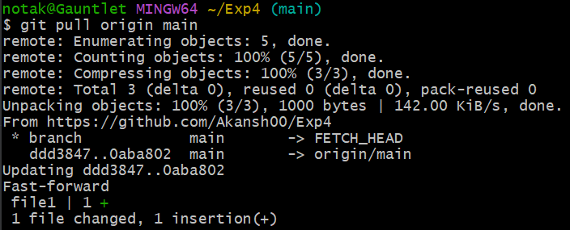

* + Now open the file to view the changes done into ‘file1’.

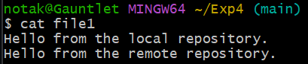

* + Then create a new branch ‘branch1’ and make some changes in ‘file1’ from within the new branch.

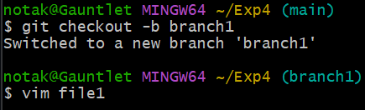

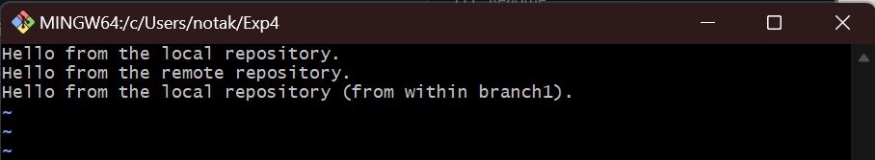

* + Merge the changes made in branch1 with the main branch after adding the changes to the staged area and committing it.

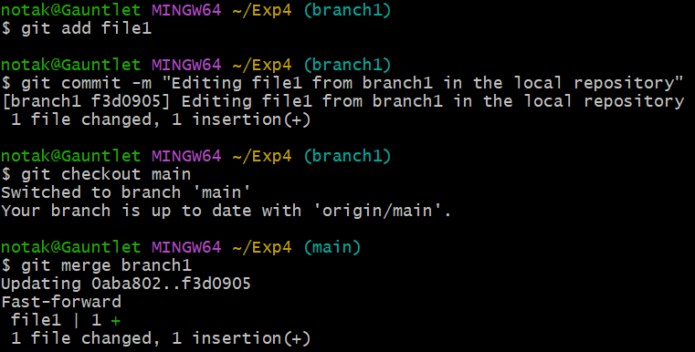

* + Then push the main and branch1 to the remote repository.

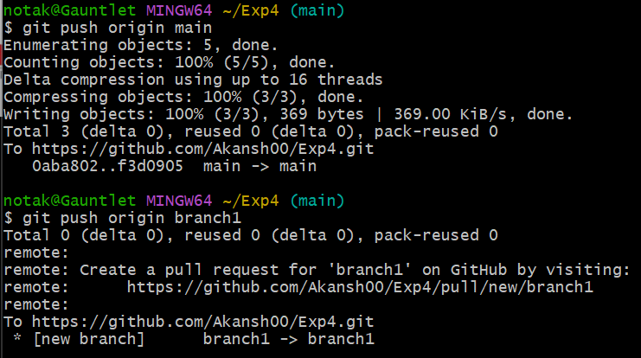

* + Now you can see the changes in the remote repository.

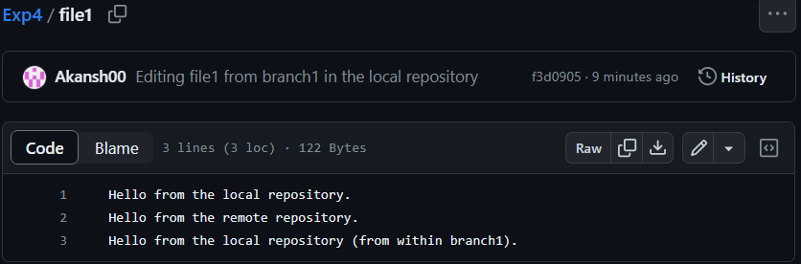

* + Now go to GitHub and in the repository, go to ‘branch1’ and make some changes in the file.

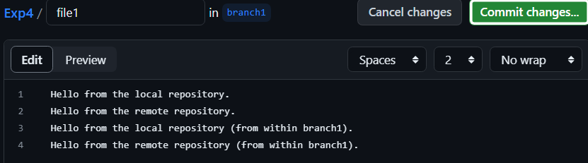

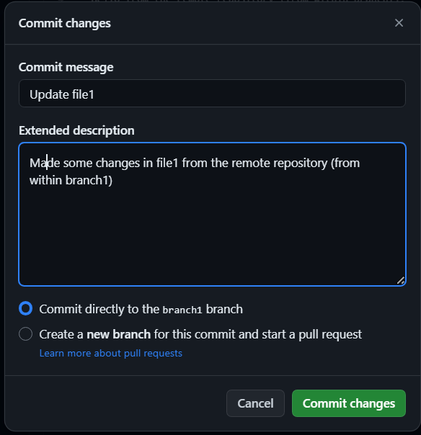

* + Now commit the changes and go to main branch to ‘Compare & Pull’ request.

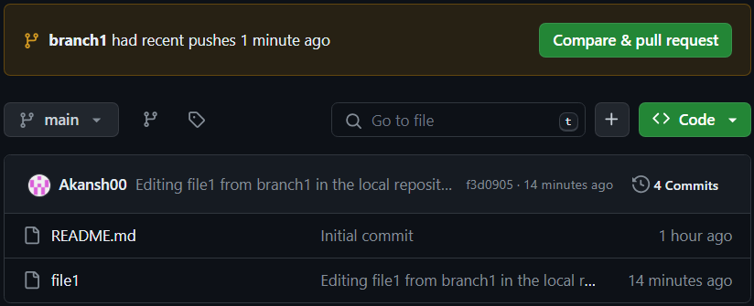

* + Now create the ‘pull request’ and after that click ‘merge pull request’, to confirm merge.

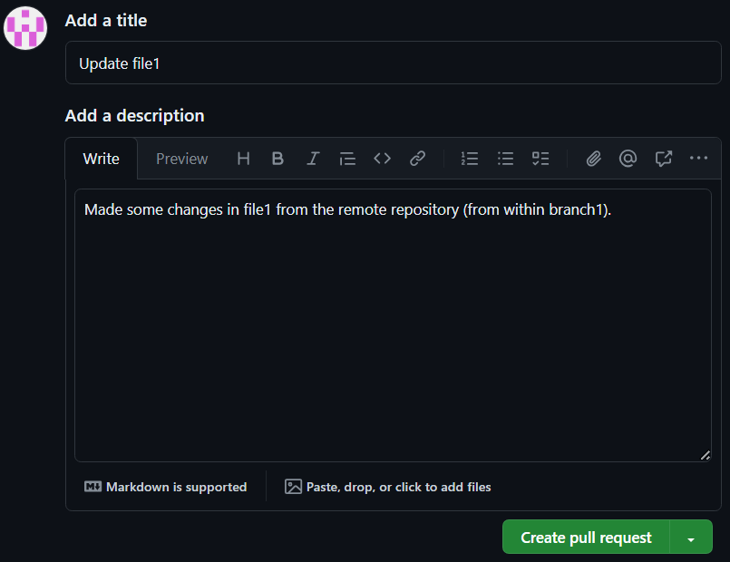

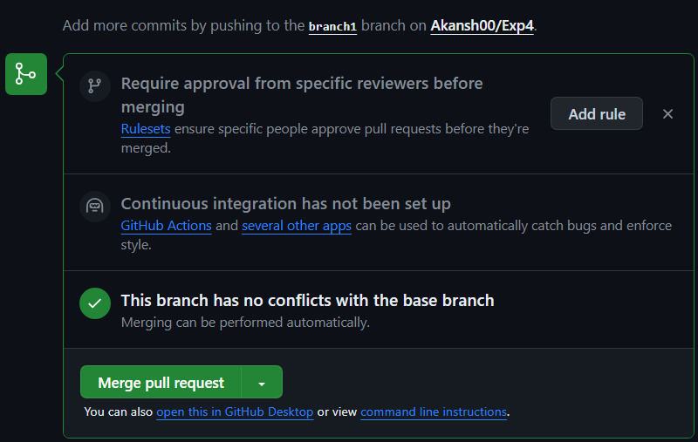

1. **Result/Output/Writing Summary:**

In this experiment, I created a repository, a file, edited the file and commit changes on Git(local) and GitHub(remote) repositories.

**Learning outcomes (What I have learnt):**

* 1. I have learnt about branches and how to create them.
  2. I have learnt about how to push and pull the changes.
  3. I have learnt about how to merge the branches.
  4. I have learnt about some new commands.
  5. I have learnt how to resolve merge conflicts.

**Evaluation Grid (To be created as per the SOP and Assessment guidelines by the faculty):**

|  |  |  |  |
| --- | --- | --- | --- |
| Sr. No. | Parameters | Marks Obtained | Maximum Marks |
| 1. |  |  |  |
| 2. |  |  |  |
| 3. |  |  |  |
|  |  |  |  |